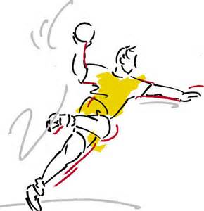
Team Handball History and Rules of the Game…

History:
The modern game actually grew out of three sports in three different European countries in the 1900’s. All three were based on soccer, but essentially replaced the foot with the hand, so that the ball could be advanced by batting or throwing rather than kicking. A German teacher added dribbling to the game as a way to advance the ball. It was designed to be played outdoors by a team of eleven (11) players and was an Olympic event in the 1936 Berlin Games. It was not played again until 1972, where it was played indoors with a team of seven (7) players. It was introduced to the United States around 1930 and was very popular in YMCA as, the US Army, boy’s and girl’s clubs, scouts, high schools and colleges. It is now played in about 150 countries.

Object of the game:
The game combines the elements of soccer and basketball, as six players move the ball down the floor that is a slightly larger than a basketball court and try to score by throwing the ball past a goalkeeper into the net.

Rules of the Game:
The ball playing rules are in 3’s
- Take only 3 steps and then have to pass or dribble
- Hold the ball for only 3 seconds
- Limit the one-head dribble to 3 (modified rules)
- Players are not allowed to punch, pull or hit the ball out of the hands of the opponent or to grab or push an opponent. This result in a free throw.
- If a ball hits the ground, the opposing team will inbound the ball from the sidelines with an overhead pass to a teammate.
- After a goal is scored, play is restarted from the center with a throw in by the non-scoring team.
- Only the goalie is allowed in the goalie area. He may use any part of his body to block a shot.
- One (1) point is given for each goal scored.
- Ball can be passed in any direction.
- Offence - To score a goal, you must leave the floor with both feet while throwing.
- Defense- you must play one-on- one (no double teaming). Players must be three feet or (arm’s length) away from the player with the ball.
- Good defense play- a player should try to intercept a pass or knock the ball to the ground. However, the ball cannot be pulled or knocked out of someone’s hand. The player with the ball will regain possession.
- Good offence play- pass the ball quickly and move with-out the ball to on open space.
- Dropped pass- is a turn over and a change of possession.

