The Nitty Gritty:

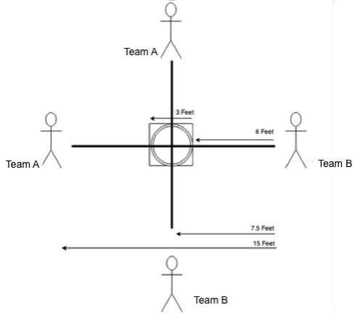

Overview
Spikeball is a team sport played by two teams of two players. Opposing teams line up across from each other with the Spikeball net in the center. The ball is put in play with a service—a hit by the server from behind the service boundary into the net to an opposing player. Once the ball is served players can move anywhere they want. The object of the game is to hit the ball into the net so that the opposing team cannot return it. A team is allowed up to three touches to return the ball. The rally continues until the ball is not returned properly.

Setup
- Equipment
  - Ball – 12 inches in circumference
  - Spikeball set – net tension should be consistent throughout
- Court Dimensions (see image above)
- Winner of rock, paper, scissors gets to pick side or serve.
- Opposing players line up across from each other.
- Before the ball is served any players not receiving the serve must be 6 feet from the net. The returner can stand at whatever distance they choose.
- Once the ball is served players can move anywhere they want.
- Possession changes when the ball contacts the net.
- Each team has up to 3 hits per possession, but they do not need to use all 3 hits.
- When sunlight is a factor, teams should switch sides half way through the match.
- When playing on grass, if one team is playing in cleats and the other team is barefoot, paper/rock/scissors is played to determine if both teams need to be barefoot, or if the barefoot team needs to wear shoes. If the barefoot team loses and wants to remain barefoot, they must do so at their own risk.

Scoring
- Rally scoring (points can be won by the serving or receiving team)
- Games are played to 21. You must win by two points. (unless otherwise specified by a tournament director)
- Switch sides after one team reaches 11 points.
- Points are scored when:
  - The ball isn’t hit back into the net within 3 hits
  - The ball hits the ground
  - The ball hits the rim (including clips) (Even during a serve--rim shots don't count as a "let")
  - The ball does not bounce off the net in a single bounce. (It must clear the rim in order to be good)
  - There is an illegal serve or other infraction

Serving
- The receiving team sets their position first. Server stands directly across from the receiving player. Only the designated receiver can field the serve.
- The ball must be tossed up from the server’s hand before it is hit. It cannot be hit out of the server’s hand. If the server does not like the toss, they need to let the ball drop to the ground. They will have one more opportunity to toss and serve the ball.
- Server's feet must be behind the service line (at least 6 feet away from the net) when the ball is hit. They can lean over the service line, but their feet may not cross the service line until after the ball is hit.
- The server is allowed to take a pivot step or approach steps, but is not allowed to move laterally beyond a pivot.
- Serves can be as hard or as soft as the server likes, and drop shots are allowed.
- Serves must be below the receiver's raised hand. If the ball can be caught by the receiver, it has to be played. If the ball is too high, the receiver must call “let” before their teammate touches the ball. The serving team has one more try to serve. If the serving team cannot hit a legal serve on the second try, they lose the point. If the receiver does not call “let”, continue play.
- The ball must come cleanly off the net on a serve. If the ball takes an unpredictable bounce (commonly known as "pocket"), the receiver must call “let” before their teammate touches the ball. The serving team has one more try to give a clean serve. If the serving team cannot hit a legal serve on the second try, they lose the point. If the receiver does not call “let”, continue play.
- If the ball takes an unpredicted bounce, and lands back on the net or the rim, it's the other teams point and a change of possession.
- If the ball contacts the rim at any time, it is a point for the other team and a change of possession.
- After a server wins the point, they change positions with their teammate so they are directly across from the other member of the receiving team.
- The four players serve in the same sequence throughout the match, changing the server each time a rally is won by the receiving team.

Contacting the ball
- Hits must alternate between teammates.
- The ball must be hit, not be caught, lifted, or thrown. You cannot hit the ball with two hands (this includes putting both hands together while contacting the ball with your hands).
- You can use any part of your body to hit the ball and it counts as your hit. (You cannot contact the ball twice in a row regardless of what part of your body it touches)
- If the ball hits any part of the ground or rim it is no good. There are only “lets” on the serve. After the serve, if the ball does not hit the rim, play it regardless of how it bounces.
- If teams cannot determine if the ball hit the rim, replay the point, no questions asked.
- Once the ball hits the net, it must bounce off in a single bounce. It must clear the rim in order to be good.

Infractions
- Defensive players must make an effort to get out of the offensive team’s way. If a member of the defensive team is in the way of a play on the ball, the player being blocked must call “hinder” and replay the point. The offensive team must have a legitimate play on the ball to call “hinder.”
- If the defensive team gets hit with the ball, call “hinder” and replay the point. The offensive team must have a legitimate play on the pass to call “hinder.”
- If a defensive player attempts to play a ball when it is not their turn, they lose the point.
- If a player hits a shot off the net then the ball hits their teammate, they lose the point. If a player hits a shot off the net then the ball hits himself/herself, they lose the point.
- If any player makes contact with the Spikeball set that moves the set or affects the trajectory of the ball, they lose the point. If the contact with the Spikeball set does not move the set or affect the trajectory of the ball, play on.

