NITROBALL | 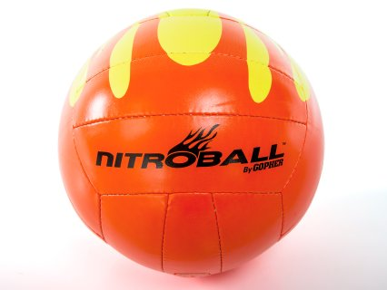 | STUDY GUIDE

History:
Nitroball was invented in the summer of 2005 in Sarasota, Florida. The game was originally created to be played on tennis courts during PE classes. The classes started playing traditional volleyball on the tennis courts and became bored with the nets being so low. They began hitting the ball down, instead of up and created “inverted volleyball”. The rules have evolved, and the name of the game changed to Nitroball.
Court & Equipment:
The Nitroball court is the same dimensions as a doubles tennis court. Those dimensions are 78’ long (sideline) and 36’ wide (baseline). The net is 39’ from the baseline and the serving line is 21’ from the net. Games may be played inside or outside using a net that is 36”-42” high. A volleyball may also be used if you do not have an official nitroball.
Scoring:
- Rally scoring is used during Nitroball games (whichever team wins the rally, earns the point).
- The first team to score 21 points wins. Teams must win by 2 points with a scoring cap of 25.
- A match consists of 3 games and the team who wins 2 of the 3 games wins the match.
Serving:
- Underhand serving is the only way to serve.
- Server must serve behind the serving line.
- Serving team loses the serve when their team loses the rally or commits a serving fault.
Game Play:
- Teams are comprised of 6-8 players.
- Once ball is served players may move around the court as needed to play the ball.
- The ball must bounce before EVERY strike (except the serve).
- A player may not hit the ball consecutively.
- Kicking or heading the ball is not permitted.
- Blocking is not allowed as the ball must hit the ground before striking.
- Ball may be struck with one hand or two hands.
- Each team may use up to three hits to get the ball over the net.
Scoring:
One point is scored each time a fault is made:
- The ball bounces twice on one side.
- The opposing team is unable to return the ball within three hits.
- The opposing team cannot legally return the ball into the court (in bounds).
- The opposing team commits a fault.
- Serving into the net.
Types of Hits:
- Spike: ball is hit hard in a downward forward direction
- Drop: ball is touched or hit lightly so that is simply drops over the net
- Bump/Forearm pass: similar to the volleyball bump; ball is hit using the forearms to pass to another teammate or over the net
- Set/Overhead pass: using your hands above your head to “set up” a teammate for a spike or hammer hit
- Hammer: using a fist you hit the ball hard and downwards
- Dig: a last ditch attempt to keep the ball from hitting the ground for a second time
Nitroball Court Diagram:
