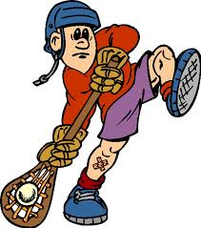 LaCrosse 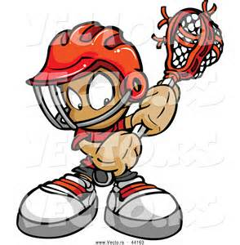

History
Lacrosse is the national game of Canada. It was invented by the Native Americans.

Terms
1. Crosse or Basket:top webbed part of the lacrosse stick
2. Shaft: handle of the lacrosse stick use shoulder width grip
3. Butt: bottom of the lacrosse stick
4. Box: area next to ear and above shoulder where carrying, catching and throwing take place
5. Soft hands: act of giving on impact when catching the ball
6. Finishing High: short abrupt follow through used when throwing
7. Smelling the Ball: having your head directly over the ball when scooping

Skills and Fundamentals
1. Carry: 1 hand or 2 hand running with the ball
2. Dodge: avoiding an opponent during a carry
3. Cradle: 1 hand or 2 hand rolling action used to keep the ball in the crosse
4. Scoop: picking up a loose ball from the ground. Three types:
•Stationary scoop-picking up a ball that is not moving
•To scoop- picking up a ball that is rolling toward you
•Away scoop- picking up a ball that is rolling away from you

5. Catch: receiving an aerial ball in the crosse or basket
6. Throw: passing the ball to a team mate or shooting on goal
7. Grip: “palm” grip with lower hand, “finger” grip with top hand

MJHS PE Lacrosse Rules 10 Member Teams

Players: team will consist of 9 players plus the goalie. This makes 10 total players on the field.

Attack: Responsibility is to score goals. The attackmen will limit their
play to the offensive end of the field and may not crosse the
midfield line. There will be three attackman.

Midfield: Responsibility is to cover the entire field, playing both offense
and defense. There will be three midfielders.

Defense: Responsibility is to defend the goal. These players are only
allowed on the defensive end of the field. There will be three
defensive players.
Offense:
The ball may be advanced by running, passing, or rolling it on the ground. Scooping may only be one on one. Scoring occurs when the ball crosses the plane of the goal. A goal attempt must be made from outside the crease area. Any goal made from inside the crease area will not be counted.There must be 2 complete passes before a team can attempt to score. A bounce pass can count as a pass.

Defense:
One on one defense must be played. No double teaming is allowed. The stick of one player may not touch another player’s stick. Defense will be played like that of basketball. Players may not purposely contact another player.

Out of Bounds:
If the ball goes out of play, the team who touched it last loses possession. The team gaining possessions will pass it in from where it went out of bounds. No defensive player may be within 5 steps of the player putting the ball back in play.

PE Fouls:
Body or sticking checking
Tripping or intentional contact
Intentional stick on stick contact
Fouls result in a free throw from the spot of the infraction. No direct throws are allowed as a result of a foul.
Men's Lacrosse Rules (May differ from PE rules) Understanding the differences is necessary.

- Each team must keep at least four players, including the goalie, in its defensive half of the field and three in its offensive half Three players (midfielders) may roam the entire field.
- Generally, high school games are 48 minutes long, with 12 minute quarters. Each team is given a two minute break between the first and second quarters, and the third and fourth quarters. Half-time is ten minutes long.
- Teams change sides between periods. Each team is permitted two time-outs each half. The team winning the coin toss chooses the end of the field it wants to defend first.
- Men's lacrosse begins with a face-off. The ball is placed between the sticks of two squatting players at the center of the field. The official blows the whistle to begin play. Each face-off player tries to control the ball. The players in the wing areas can release; the other players must wait until one player has gained possession of the ball or the ball has crossed the goal line.
- Center face-offs are also used after a goal and at the start of each quarter.
- Players may run with the ball in the crosse, pass and catch the ball. Only the goalkeeper may touch the ball with his hands.
- A player may gain possession of the ball by dislodging it from an opponent's crosse with a stick check, which includes the controlled poking and slapping of the stick and gloved hands of the player in possession of the ball.
- Body checking is permitted if the opponent has the ball. However, all contact must occur from the front or side, above the waist and below the shoulders. An opponent's crosse may also be stick checked if it is within five yards of a loose ball or ball in the air.
- If the ball or a player in possession of the ball goes out of bounds, the other team is awarded possession of the ball. If the ball goes out of bounds after an unsuccessful shot on goal, the player nearest to the ball when and where it goes out of bounds is awarded possession.
- An attacking player cannot enter the crease around the goal, but may reach in with his stick to scoop a loose ball.

