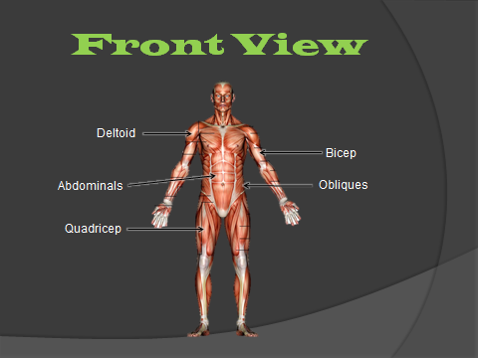
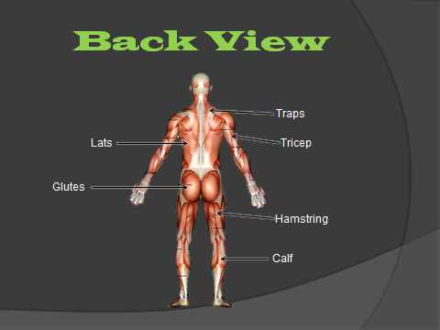
Aerobic Conditioning
- Aerobic means “with oxygen”
- Endurance activities that last a long period of time
  - Examples: jogging, jump roping, waling, swimming, biking, soccer, basketball, hockey
  - Benefits
    - Improves cardiovascular system
    - Weight control
    - Reduces stress
    - Reduces the risk of developing heart disease
    - Reduces the risk of developing diabetes
    - Reduces the risk of developing certain kinds of cancer
Anaerobic conditioning
  - Anaerobic means “without oxygen”
  - Exercises that are short, abrupt, and high intensity
    - Examples: 50 yard sprint or lifting weights
  - Benefits
    - Burns more fat
    - Increase endurance

Resting Heart Rate
  - The number of times your heart beats in a minute when you are resting (or sleeping)
    - Taken when you wake up or after 10-15 minute rest
    - An average adult human heart beats about 72 times a minute at rest
Target Heart Rate Zone (THRZ)
  - Your “target heart zone” is between 60% and 85% of your maximum heart rate
Maximum Heart Rate (MHR)
  - The maximum number of times your heart can beat in a minute
    - MHR= 220 minus you age
- The key to a good aerobic work out is to exercise within you “zone”.
F.I.T.T.
- F: Frequency- exercise 3-4 times a week
- I: Intensity- Exercise hard enough so that you are in you “zone”
- T: Time- exercise aerobically for 20-40 minutes
- T: Type- the type of exercise you are doing
A workout should consist of 3 points
  - Warm-up: to stretch the muscles and to increase the blood flow to the muscles
  - Exercise: Aerobic, Anaerobic, Strength, Training
  - Cool-down: to return the body to its “normal state”

