Badminton Study Guide
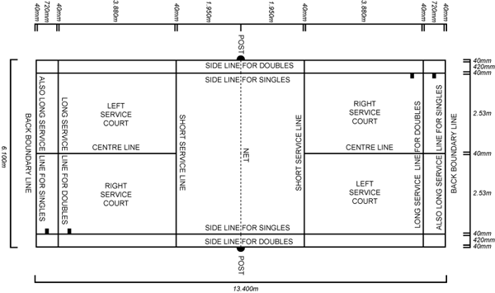

History:

Badminton originated from the ancient game “Battledore and Shuttle cock” played in Siam and China over 2,000
years ago. A modified version of this sport known as “Poona” in India caught the attention and enthusiasm of
British Army officers stationed there, who later brought the game home to England around 1870. The Duke of
Beaufort gave real momentum to the game at his estate, Badminton House, in Badminton, Gloucestershire.
The game spread rapidly throughout the world and reached America via Canada.

Scoring System:

A match consists of the best 2 out of 3 games played to 21 points.

The side winning a rally adds a point to its score.

At 20 all, the side which gains a 2 point lead first, wins that game.

At 29 all, the side scoring the 30th point, wins that game.

The side winning a game serves first in the next game.

Points: - Singles

At the beginning of the game and when a team’s score is even, the server serves from the right service court.
When it is odd, the server serves from the left service court.

If the server wins a rally, the server scores a point and then serves again from alternate service court.

If the receiver wins a rally, the receiver scores a point and becomes the new server.

Points: - Doubles:

Which ever service court a player begins in for the first serve is called their home position. When the team’s
score is even, a player should serve or receive in their home position. When the team’s score is odd,
a player should serve or receive opposite their home position.

At the beginning of the game and when the score is even, the server serves from the right court.
When it is odd, the server serves from the left court.

If the serving side wins a rally, the serving side scores a point and the same server serves again from
the alternate service court.

If the receiving side wins a rally, the receiving side scores a point. The receiving side becomes the new
serving side.

The player of the receiving side who served last stays in the same service court from where he/she served last. The reverse pattern applies to the receiver’s partner.

The players do not change their respective service courts until they win a point when their side is serving.

If players commit an error in the service court, the error is corrected when the mistake is discovered.

Side by side or up and back strategies can be used in doubles.

Service Rules:

On the serve the shuttle must be contacted below the waist and the whole head of the racket must be below
the wrist. This assures that the serve is an underhand serve.

A serve may not be delivered until the receiver is ready. If the receiver plays the serve, the receiver is
considered ready.

During the serve it is a fault if:
- The shuttle is contacted above the server’s waist or the racket head is above any part of the hand.
- The shuttle does not fall into the diagonally opposite service court.
- Some part of both feet of the server and the receiver are not in contact with the appropriate court.
- Either the server or receiver fakes or balks.
- If the server misses the shuttle completely, the server may not serve again (fault).

General Play:

- A shuttle landing on the line is considered good.
- A shuttle which touches the net and passes over the net is in play whether it’s on the
serve or any other shot.

It is considered a fault if:
- The shuttle fails to pass over the net or lands outside the boundary lines.
- The shuttle contacts the wall, ceiling, player, or player’s clothing.
- The shuttle passes through the net.
- A player reaches over the net to make contact with the birdie.

Terminology

ALLEY: The area on each side of the badminton court between the doubles sideline and the singles sideline; about one and one half feet wide.

BACKCOURT: The playing area between the front service line and the baseline.

BACKHAND: A stroke on the left side of the body executed with the right arm and racket across the body.

BACK LINE: The boundary lines farthest from the net.

CLEAR: A stroke that sends the shuttle high and deep into the opponent’s backcourt, a lob.

CROSS-COURT: A stroke that sends the shuttle on a diagonal flight.

DRIVE: A sharply hit stroke that sends the shuttle low over the net and on a horizontal flight.

DROP SHOT: A shot flies close to the net and the quickly drops into the opponent’s forecourt.

DOUBLE HIT: Hitting the shuttle twice in succession on the same stroke. This is illegal.

FAULT: Any playing error or violation of the rules.

FORECOURT: The playing area between the short service line and the net.

FOREHAND: A stroke executed on the right side of the body.

HAIR PIN NET SHOT: A shot that skims over the net and falls sharply.

LET: A serve that touches the net and drops into the proper service court, considered a good serve.

RECEIVER: The players who is to receive the serve.

SHORT SERVICE LINE: A line on the court which runs parallel to the net at a distance of 6 and a half feet from it; also called the front service line. All serves must cross the line.

SMASH: A powerful overhead stroke in which the shuttle is hit sharply downward.

